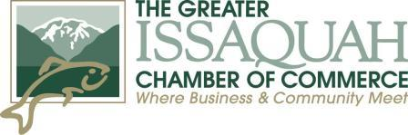
For Information Contact:
Brenda DeVore, Community Engagement & Events Manager
The Greater Issaquah Chamber of Commerce
155 NW Gilman Blvd., Issaquah, WA 98027
programs@issaquahchamber.com
Fb | Instagram: @IssaquahChamber 425.392.0661
PRESS KIT

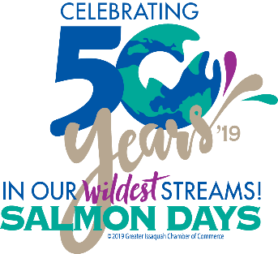
Greetings event partner:
Here is your press kit designed to give you an easy way to post information to promote the Issaquah Salmon Days Festival.
Everything is prepared for you to copy and paste. However, please know that you can modify and create copy to better suit your business.
- The links will show you what has been created on our end and each type of release has built in URL’s to the registration page.
- The Press Release can be used in your newsletters, on your blogs, social media, as your own press release, sent to your local city marketing departments, newspapers, etc.
- Like and share the post from our Facebook, Instagram and Twitter posts: @SalmonDays #SalmonDays
- The photos and logos are for you to upload to go with the posts; we do recommend the Issaquah Salmon Days logo and another picture if possible. As we all know, video is the key to success on social media; please post video whenever possible.
We are very excited to partner with you and bring this event to the community.
For more information contact:
Greater Issaquah Chamber of Commerce
155 NW Gilman Blvd. Issaquah WA 98027
425-392-0661
Contact Person: Community Engagement and Special Events Manager, Brenda DeVore
programs@issaquahchamber.com

Links:
Website: www.salmondays.org
Facebook Event Page: https://www.facebook.com/salmondays/
Fb | Instagram: @SalmonDays
Event hashtag: #SalmonDays

For Information Contact:
Brenda DeVore, Community Engagement & Events Manager
The Greater Issaquah Chamber of Commerce
155 NW Gilman Blvd., Issaquah, WA 98027
programs@issaquahchamber.com
Fb | Instagram: @IssaquahChamber 425.392.0661
FOR IMMEDIATE RELEASE

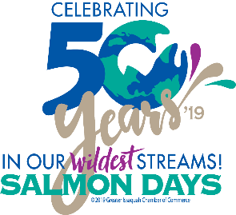

Issaquah Salmon Days Festival 2019- 50th Year
October 5-6th 10am – 6pm
www.SalmonDays.org

July 18th, 2019, Issaquah, WA. The Greater Issaquah Chamber is proud to produce the largest 2-Day festival in the state – Salmon Days. Salmon Days is a long-standing family friendly event that started 49 years ago to promote stewardship of our local salmon and streams. Each year over 150,000 local and regional guests venture to Issaquah to welcome our salmon home.

The Issaquah State Salmon Hatchery is the heart of the event. 1000's of Salmon return home each fall to spawn in the Issaquah Creek. The hatchery offers free tours, and educational talks about our precious salmon. Salmon Days has added food, vendors, attractions and activities for the entire family to make your visit worth the entire weekend!

Award winning!
  - Seafair Sanctioned Event
  - 425 Magazine voted Salmon Days as Best Festival for 2018
  - Travel Channel announced Salmon Days as the Best Festival in Washington for 2018

Parade
- The Grande Parade is on Saturday October 5th and begins at 10am and features more than 100 entries, including floats, clowns, marching bands, equestrian entries, school groups, and dance teams.
- This year’s parade Grand Marshal is Bryan Clay, the “World’s Greatest Athlete.” He is an Olympic Decathlon Gold and Silver Medalist and three-time World Champion and Issaquah resident. www.bryanclay.com
- To be in the parade, register at: http://www.issaquahchamber.com/sd-2018-parade.

Booths
- 300 juried arts and crafts vendors offering every unique gift and treasure you could imagine.
- Farmers Market with 30 fresh fall produce and local maker food booths.
- The festival provides an opportunity for over 50 local non-profit organizations to participate through fundraising.
- To apply for a booth: https://www.issaquahchamber.com/sdvendors

Food
- The Kiwanis salmon barbeque is a perennial favorite.
- Over 50 food vendors representing foods from around the world.

Entertainment
- Entertainment abounds with 40+ musical bands playing on four stages and family friendly entertainment. An exciting line up of entertainment is being planned for our 50th year. Because this is also the 50th anniversary of the famous Woodstock concert, we will be presenting a special tribute to the music of the Woodstock era with a NW All Star band to round out the festival on the Sunday afternoon.
- Streaming Live! Lounge is an outdoor venue designed specifically for teens. Entertainment for this location will consist of teen bands, DJs, rock climbing, corn hole games and more.
- The Main stage features a beer garden and covered area with big screens to view sporting events.
- Sip & Save The Salmon Wine Tasting featuring local wineries, breweries and cideries with an opportunity to donate to FISH.

Families & Children
- Young attendees have tons of FREE activities in the Field of Fun including Mini Train rides, inflatables, face painting, fish prints, trampoline jumping, the ever-popular Dock Dogs and more!
- FREE tours of the Issaquah Salmon Hatchery

5K Rotary Run
- All ages 5K run put on by the Issaquah Rotary Sunday morning. Register at: http://issaquahrotary.org

Go Green!
- We are a plastic bag and balloon free event.
- Food vendors utilize only compostable and/or recyclable containers.
- All used oil from food vendors is collected and donated to a company who converts it into biofuel.
- There are also recycling and compostable stations throughout the festival grounds next to all trash bins.

Volunteers Needed
- The Salmon Days Festival is a true community collaboration with over 600 volunteers working over 3,500 hours lending a hand to bring this tradition to life each year. Many of these volunteers have participated for over 30 years!
- There are a variety of volunteer opportunities for the busiest of schedules and all skill levels. All opportunities are for ages 14 and over except for the Field of Fun Fish Prints or Toymakers Workshop where parents can volunteer with their under 14-year-old child!
- This is a fun way for families, neighborhood groups, friends and co-workers to give back to our community, earn volunteer hours and connect so join us today!

Getting to the Festival
- Shuttle Locations ($4 roundtrip, Hours of Operation: 9am to 7pm)
- Costco Corporate parking lot – 830 Lake Drive
- Issaquah Highlands - parking garage east of Regal Cinema
- Issaquah Transit Center/Park n’ Ride at Maple & 900 – 1050 17th Ave Nw
- There is also street parking and paid parking lots (help a local non-profit by utilizing these lots) close to the Festival but they fill up fast so get there early!
- Disabled Parking Locations

- Dollar Tree
- Community Center
- Issaquah Library
- Bank of America
- Confluence Park

For additional information about volunteering, parade participation, spawnsorship and vendors please visit our website: www.issaquahchamber.com/salmondays or email us at programs@issaquahchamber.com

Thank you to our community partners: The City of Issaquah, Issaquah Arts Commission, Kiwanis Club of Issaquah, Issaquah Rotary, Issaquah Senior Center and Issaquah History Museums.

The mission of The Greater Issaquah Chamber of Commerce is to be the catalyst for business growth, the convener of leaders and influencers, and the champion for the business community.

###

Images for Posts:
Logo:
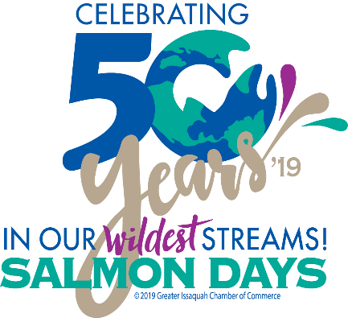
Facebook | Instagram: @SalmonDays #SalmonDays

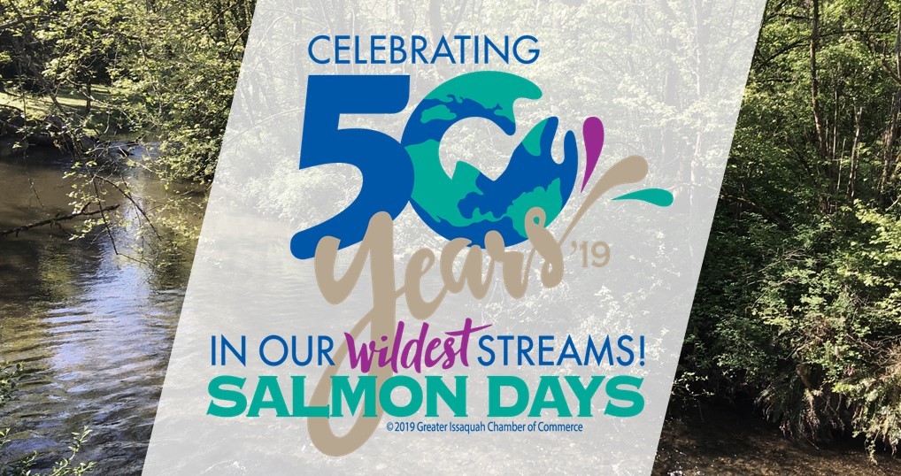

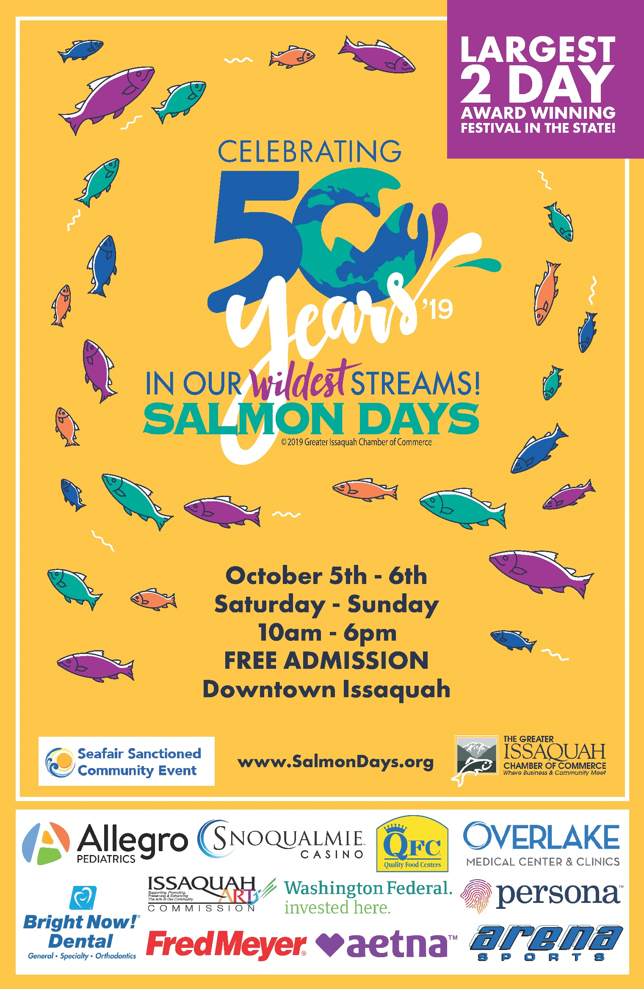

Photos of Interest and for Social Media:
Entertainment (Stages & Grande Parade):
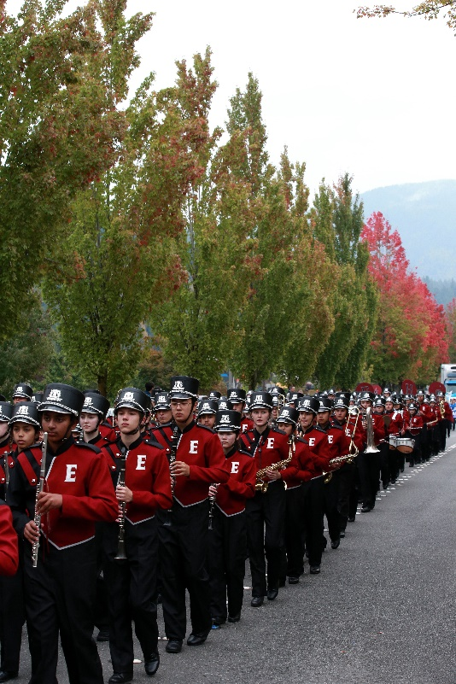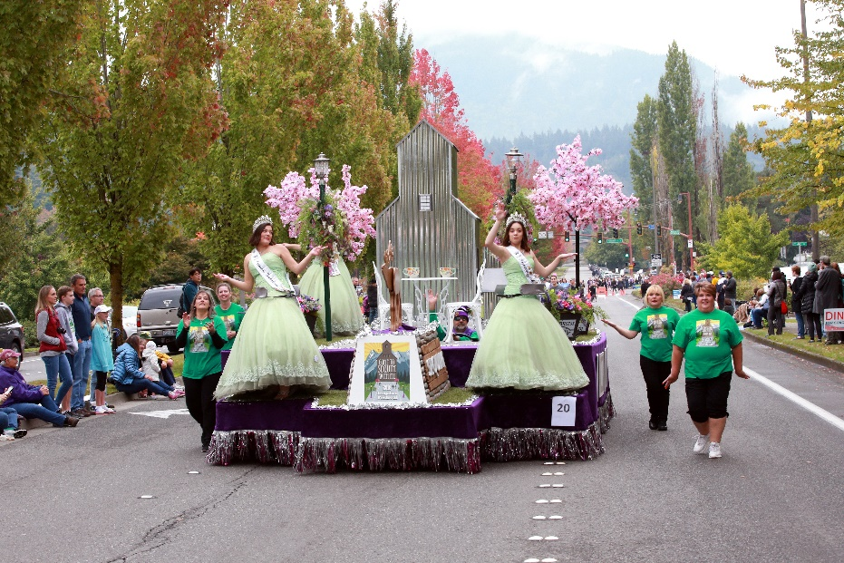

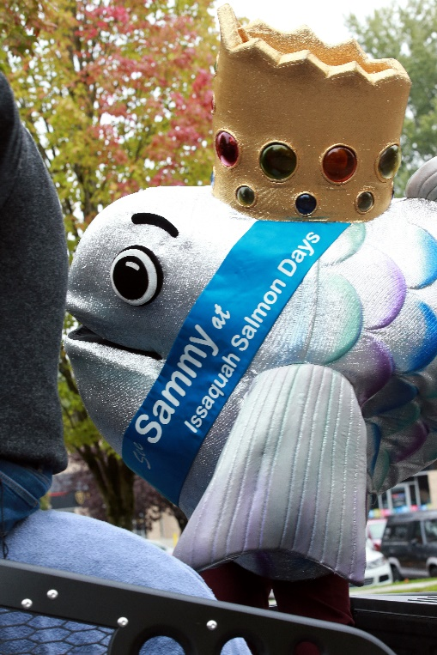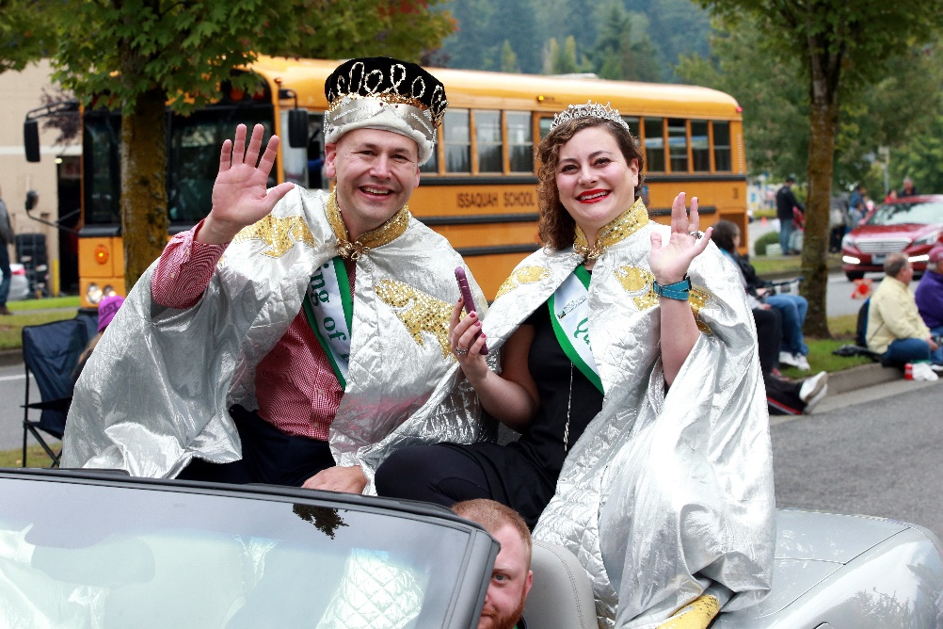
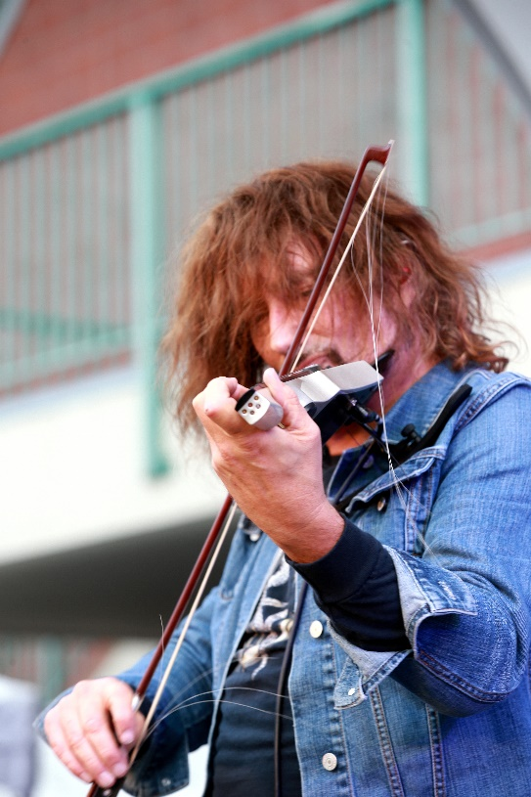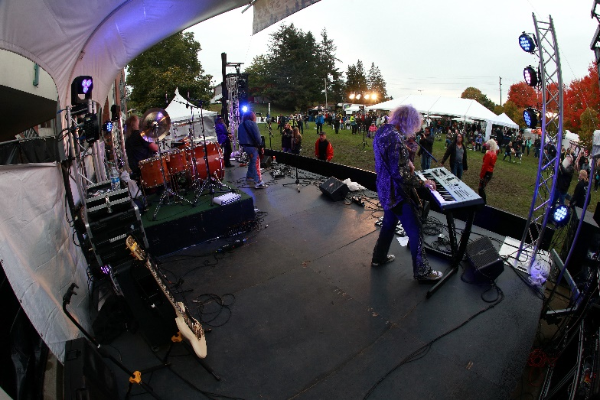
Event Location:
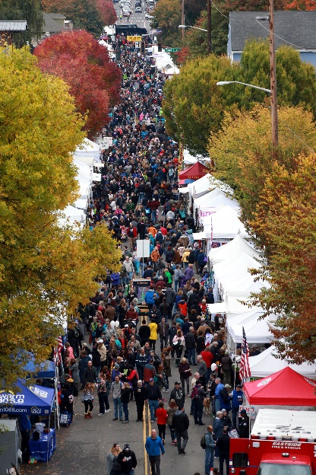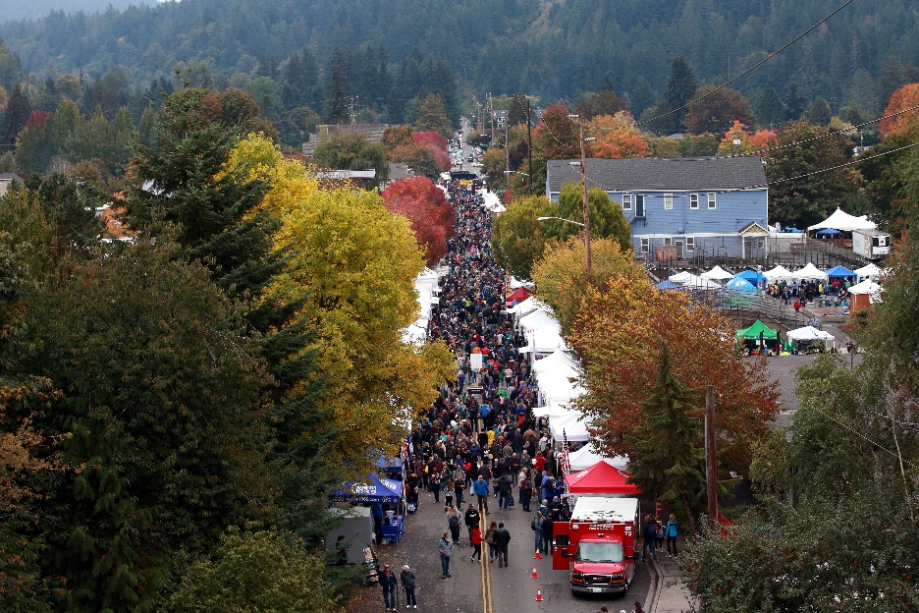
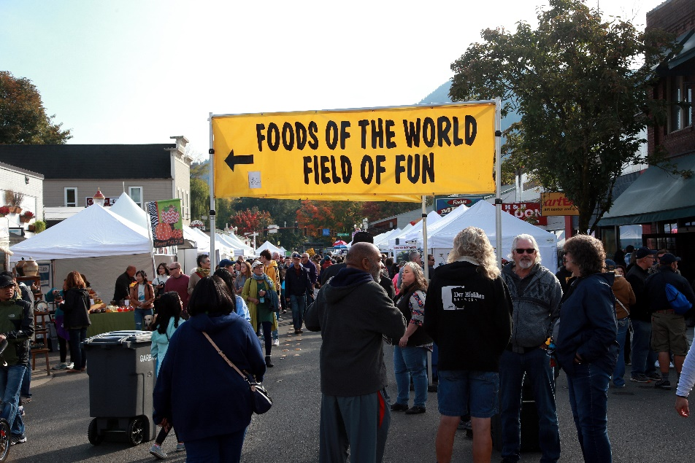

Field of Fun
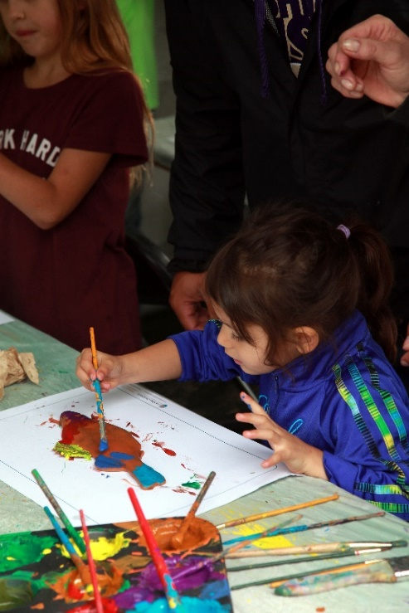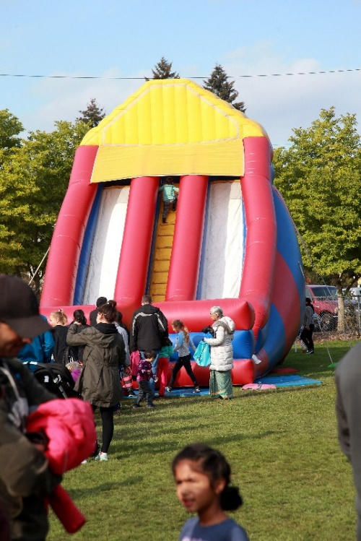
Wine Garden
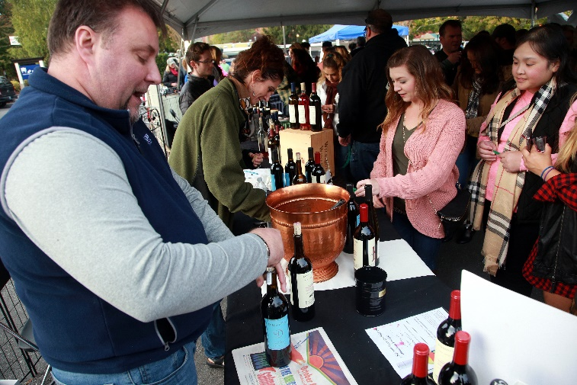
Kiwanis Salmon Bake
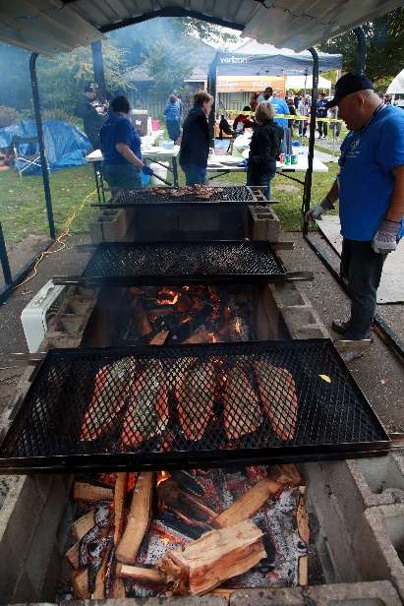

Issaquah Salmon Hatchery (Friends Of Issaquah Salmon Hatchery- FISH)
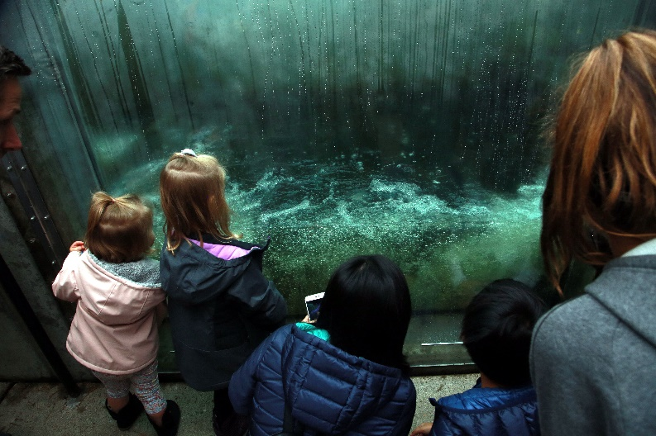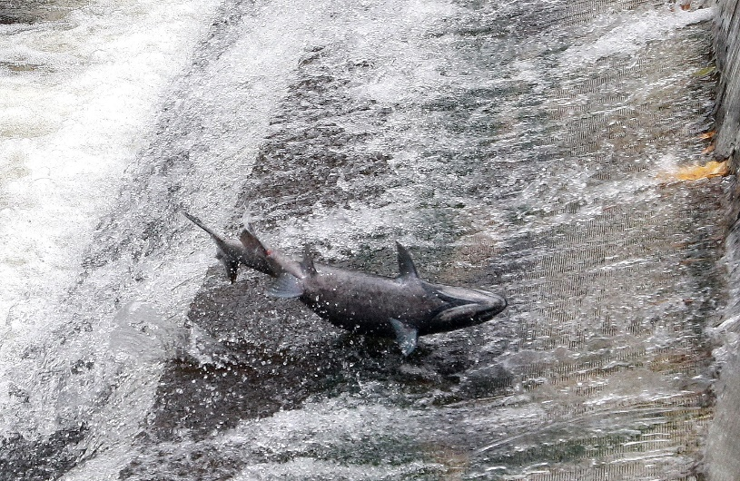

Booths (Arts & Crafts, Food and Spawnsors)
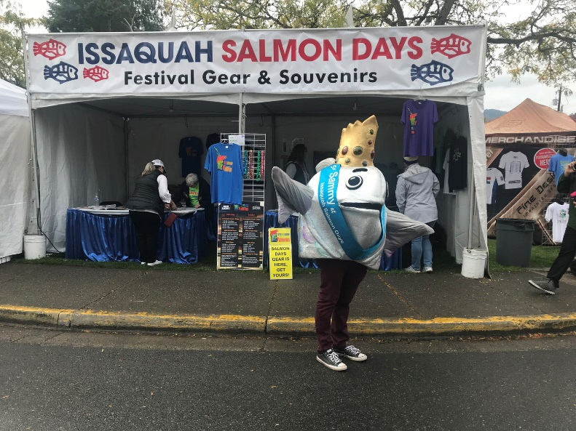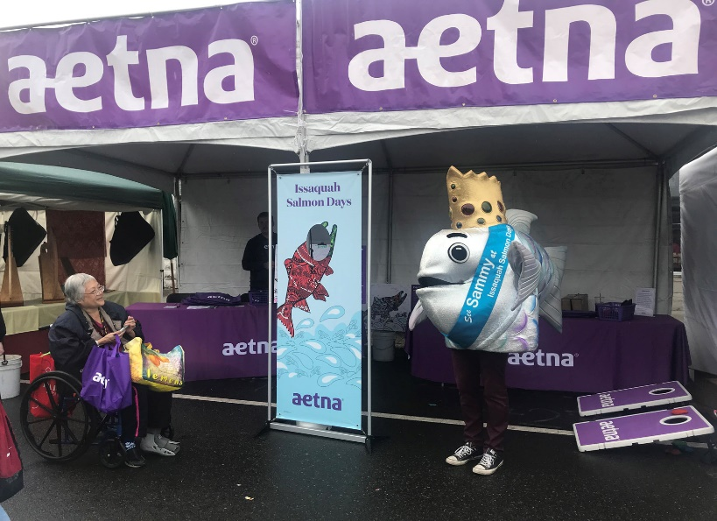
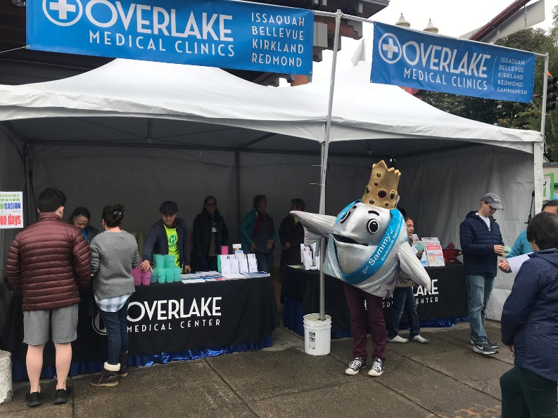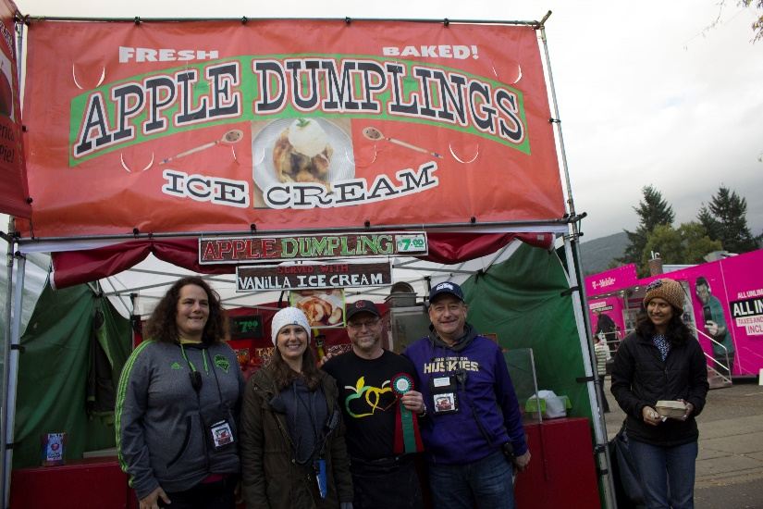

Carnival
